**VJEŽBA**

**1. PONUĐENE RIJEČI UMETNI U REČENICE:**

A COAT A CAP BOOTS SKIRT

It is snowing. I am wearing ________________________ and _____________________.

It is hot. I am wearing _______________________ and _________________________.

**2. PROMOTRI ČRTEŽ I NADOPUNI REČENICE RIJEČIMA IZ OKVIRA:**

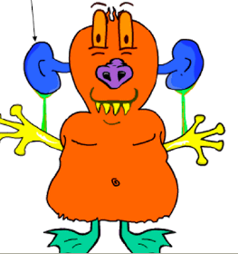

NOSE, LEGS, FINGERS, EARS, NECK, HAIR

This is Loopy. He has got two big ________________, one _________________, one short _________________, eight _________________, two short _________________ and no _________________.